- GENERATE RAW MOCK DATA

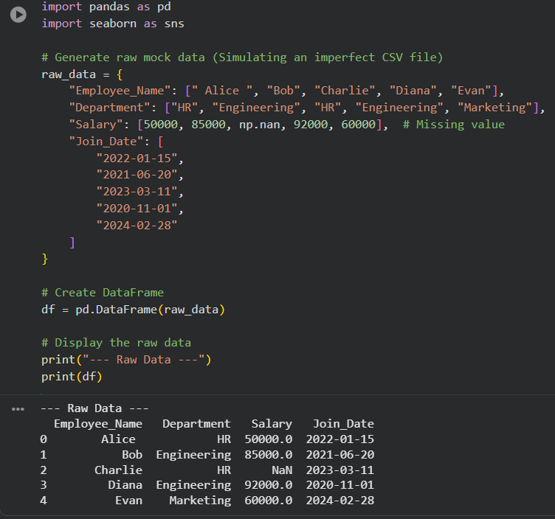

- DATA PREPROCESSING
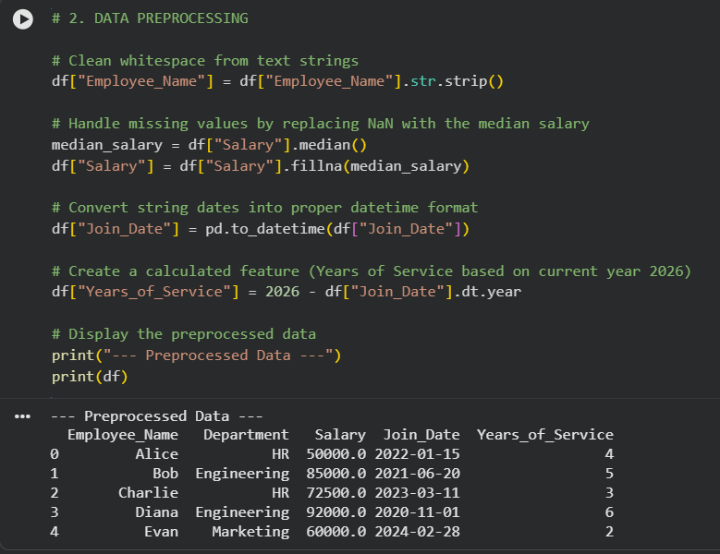
- DATA AGGREGATION
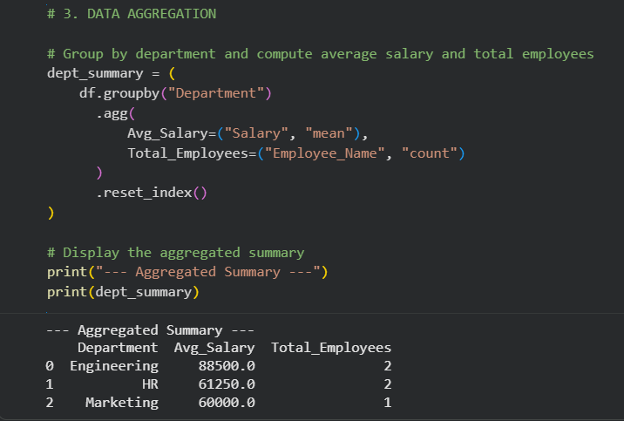
- DATA VISUALIZATION
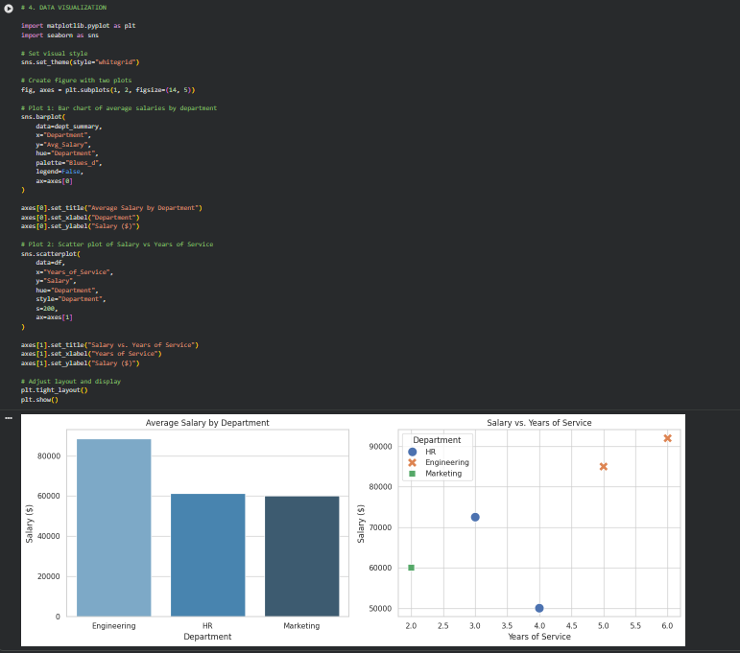

- Creating Sample DataFrame
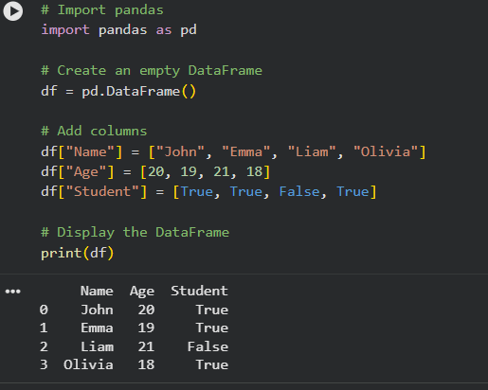
- Adding Row to DataFrame
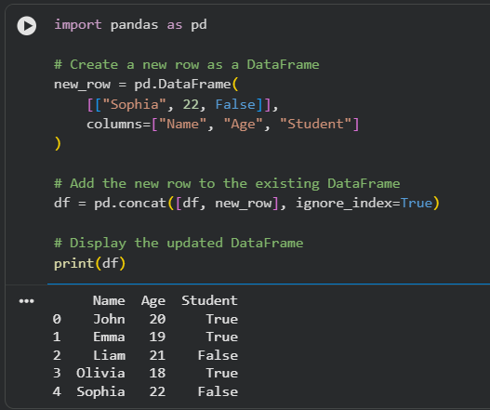
- Data Analysis with SciPy
  - Measures of Central Tendency Using SciPy
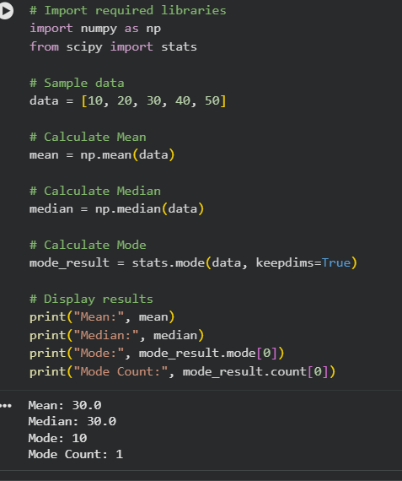
  - Probability Distribution Analysis Using SciPy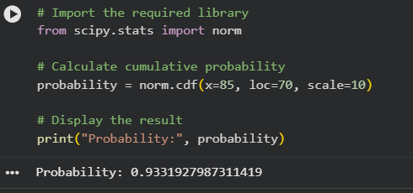

  - Hypothesis Testing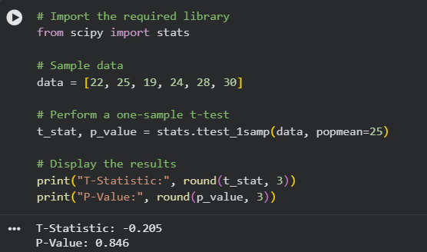

  - Correlation Analysis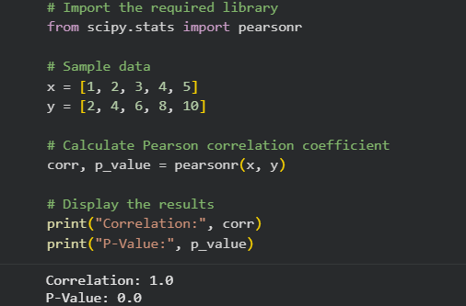

  - Linear Algebra Operations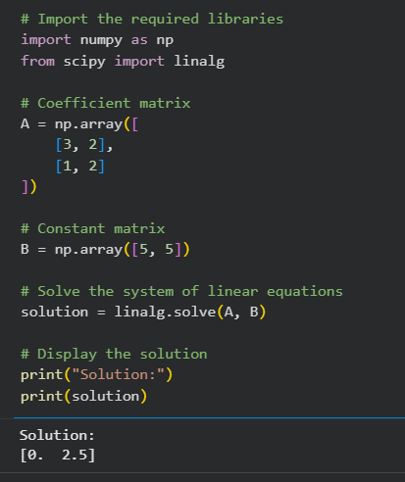

  - Optimization Using SciPy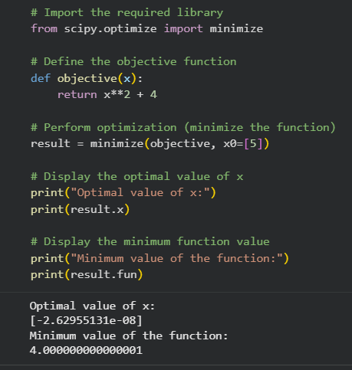

- Scikit Library in Python
  - Supervised Learning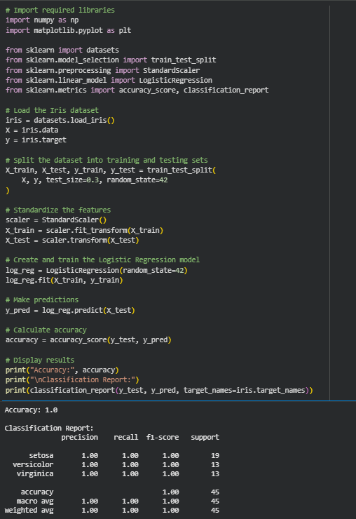
  - Unsupervised Learning